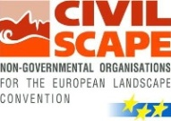

BALTIC LANDSCAPE FORUM

Landscape activities and Techniques of Public awareness raising and involvement:
European citizenship and territorial participation
Vilnius University, Faculty of Nature sciences, M. K. Čiurlionio str. 21/27, Vilnius

Preliminary Program

13th of December, Friday
13.00 Welcome coffee

13.30-13.50 Opening speech:
Representative of the Ministry of Environment of the Republic of Lithuania
Representative of Vilnius University
Dr. prof. Dovilė Krupickaitė, the President of Lithuanian geographical society
13.50-14.10 “Understanding of landscape”. Dr. Gerhard Ermischer, the Vice-President of CIVILSCAPE,
14.10-14.30 “Landscape Forum events in Europe 2013”. Dirk Gotzmann, the Director of CIVILSCAPE,
14.30-15.00 “The activities of Lithuanian geographical society implementing of European Landscape convention”. Dr. Giedrė Godienė, Lithuanian geographical society
15.00-15.30 Presentations of partners of the international project LIFESCAPE, orientated to the fostering the implementation of the European Landscape Convention in the South Baltic region.
Daiva Abrutė, Žemaitija national park, Lithuania
Katarzyna Fidler, External Project Coordinator, Biuro Projektów Fidler, Germany
15.30-16.00 “The planning process of the National landscape plan of the Republic of Lithuania”. Prof. habil. dr. Paulius Kavaliauskas, Vilnius University
16.00-16.15 "Facilitating Public participation in Landscape Architecture by Virtual Simulation Tools". Gintaras Stauskis Prof. Department of Urban Design Vilnius Gedimino Technical University
16.15-16.30 “The findings of Gargždai town community, developing and implementing the Gargždai park Feasibility study (Klaipėda district municipality)”. Matas Cirtautas
16.30.-16.45 “The experience of Užupis community, taking part in the Project of industrial cite conversion into the living environment in the high value landscape close to the UNESCO site – Vilnius old town”. Sakalas Gorodeckis, Užupis community
16.45- 17.30 Discussions and reflections

14th of December, Saturday
Excursion 10.00-14.00
Vilnius landscape changes and challenges: Modern City; Old town and surroundings; Subnatural valley of Vilnelė river (Pučkoriai cliff)
Vilnius has big variety of landscapes, famous for naturalness and beauty, historic centre of the city is UNESCO protected since 1994.
On the area is 392 km² within the administrative borders close to the 44 % is covered by forests and parks, lakes, characterized by rich biodiversity. There are 2 municipal regional parks in Vilnius (in the Verkiai regional park forests cover up to the 80% of the area) with total area of the 4827 ha.
Vilnius is situated on the unique contrasting terrain of several natural landscape types, on the confluence of Neris and Vilnelė rivers. The natural aesthetic of the city is related with different natural terrains: an erosive ridge isolated by steep slopes (Sapieginė); terraced, cascading slopes formed by Neris and Vilnia, which create a natural amphitheatre (Old Town); plateau (Naujamiestis); Vilnia canyon (Paplauja with neighboring Rasos and Užupis; from the South and the West, the city is surrounded by moraine highland.
When the thawing of the last glacier started, proglacial lakes were formed shaping the land surface at 160 to 140 m NN. Once the fluvial processes started, directed water flows began to erode the Neris and Vilnia old river valleys and to form terrain at 140–145 m NN. Neris formed a 3–4 km wide valley, in which terraces were formed. Pučkoriai is the highest active moraine cliff 5 km from the city centre which absolute high is 65 m.
Natural diversity is enriched with the cultural insights, have different history. You can find modern city centre and medieval Old town, residential areas of different age and style, modern and historic gardens.
During the excursion You will explore the dynamism of contemporary City, the mysterious Old town and the calmness of natural areas of Vilnius. There will be opportunity to experience the ratio between the natural and social forces, discuss historic and recent changes on these areas, the most interesting projects, role of different stakeholders.
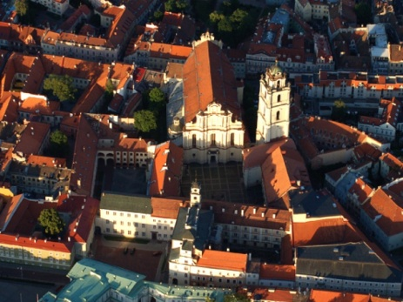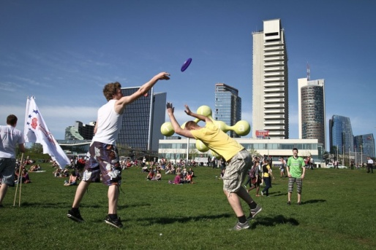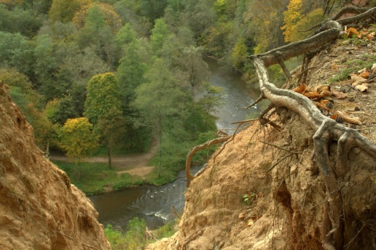

For the further information please contact Lithuanian geographical society (G. Godienė: g.godiene@gmail.com)

Organizers:
Lithuanian geographical society  dr Giedrė Godienė  M. K. Čiurlionio str. 21/27,  LT-03101, Vilnius  Lithuania  phone:.+370 68563451  e-mail: g.godiene@gmail.com  dr. Dovilė Krupickaitė, president  e-mail: dovile.krupickaite@gf.vu.lt | CIVILSCAPE  Dirk Gotzmann  Adenauerallee 68  53113 Bonn  Germany  phone:+49 (228) 299711-01  mobil:+49 (228) 299711-02  e-fax:+49 (228) 299711-09  e-mail: dirk.gotzmann@civilscape.eu

Ministry of Environment of  the Republic of Lithuania  Vidmantas Bezaras,  Director of the Department of Protected areas and Landscape  Jakšto 4/9, Vilnius LT-01105,  phone: +370 5 2663659, faks.: +370 5 2663663,  e-mail: v.bezaras@am.lt | Lithuanian association of landscape architects  Vaiva Deveikiene, president  Kalvarijų str. 1,  LT–09310 Vilnius  phone: +370 65 281174  e-mail: info@lkas.lt

